**Experiment No. 7**

**Title: Simulation of Cafeteria**

# Batch: A4 Roll No.: 1914078 Experiment No.: 7

Aim: To Implement the model for Cafeteria using Extend Sim and estimate system performance.

**Resources needed:** Extend Sim 10.0.7

# Theory

**Problem Statement:**

People arrive at a self-service cafeteria at the rate of one every 30 sec (Arrivals are Poisson distributed). 40% got to sandwich counter, where one worker makes a sandwich in approximately 60 sec. The rest go to the main counter; where one server spoons the prepared meal onto a plate in approximately 45 sec. All the customers must pay a single cashier, which takes approximately 25 sec., for all customers eating takes approximately 20 min. After eating 10% of the people go back for dessert, spending an additional 10 min (approx) altogether in the cafeteria. Simulate until 100 people have left the cafeteria, how many people are left in the cafeteria and what are they doing at the time the simulation ends. Except for the arrivals all the other data are exponentially distributed.

Model the problem as a queuing system. Animate the model in 2D.

Run the simulation till 100 people have departed from the system.

Plot and verify the following results

* Length of the queue against the number of jobs exited from the system.
* Display how many people are in the system when the simulation ends and what they are doing.

# Concepts:

**Discrete Event Model**

Simulating a system or process provides a quick and cost effective method for determining the impact, value and cost of change. Simulation models allow for time compression, are not disruptive of the existing system, and are more flexible than real systems. They also provide metrics for meaningful analysis and strategic planning.

Discrete event modelling is an integral part of Six Sigma, business engineering, risk analysis, capacity planning, throughput analysis and reliability engineering projects. The discrete event model is also useful for examining the effect of variations.

# Conceptual Model assumptions:

The Cafeteria model represents a business operation where customer are given service. The assumptions for the model are:

* The model runs until 100 customers are exited from the system
* Arrival of the customer is Poisson distributed with mean 30.
* All other service times are exponentially distributed with the specified means
* The blocks come from the Item, Value, and Plotter libraries

# Procedure / Approach /Algorithm / Activity Diagram:

# Steps:

Starting a model and setting simulation parameters

*The following steps are typical when starting any discrete event model.*

* + *Open a new model worksheet*
  + *Give the command Run > Simulation Setup. In the Setup tab enter the simulation parameters:*
    - *Global time units: seconds*
  + *If they aren’t already open, open the Item, Plotter, and Value libraries*
  + *Place an Executive block (Item library) on the top left corner of the model worksheet*
  + *Open dialog of the Executive block ; control tab; select options;*
    - *Stop Simulation: when count connector value>=;enter 100.*

The Executive block does event scheduling and manages discrete event simulations. It must be present in every discrete event model.

**Start small**

In building any simulation model, start with a simple subset of the process and add detail until you arrive at a completed model that approximates the system that’s being modelled.

The following table lists the blocks that will be added to the worksheet and their use in the model.

Except for the Plotter block from the Plotter library and random number block from value library, the blocks in the table are from the Item library.

# Name (Label) Block Function

**Create block (**customers) Generates items or values, either randomly or on

schedule. If used to generate items, it pushes them into the simulation and should be followed by a queue-type block.

# Purpose in Cafeteria Model

Generates customers that arrive as per Poisson process

***Set* (Item > Properties)** Attaches user-assigned properties (attribute, priority,

and quantity) to items passing through.

# Purpose in Cafeteria Model

Set property as preference (sandwich or meal) and further dessert or no dessert

**Queue block**(Entry Line) Acts as a sorted queue or as a resource pool queue. As a

sorted queue, holds items in FIFO or LIFO order, or sorts items based on their attribute or priority.

# Purpose in Cafeteria Model

Holds the customers and, when the server is available, releases one by one in first-in, first-out order.

***Select Item In* (Item > Routing)** Selects an input and outputs its item.

# Purpose in Cafeteria Model

For merging the two inputs (customers coming from sandwich counter and meal counter towards) and output one (one cashier).

***Select Item Out* (Item > Routing)** Sends each item it gets to a selected O/P

# Purpose in Cafeteria Model

Apply the routing rule 40% go to sandwich counter, others go to meal counter and the dessert routing rule 10% have dessert and others don’t have.

**Activity block**Server) Processes one or more items simultaneously. Processing

time is a constant or is based on a distribution or an item’s attribute.

# Purpose in cafeteria Model

Serves the customers as per the service distribution i.e. exponentially distributed

**Random Number block** Generates the random numbers

# Purpose in cafeteria Model

Outputs values to a Set block as per the look up table

**Exit** (Exit) Removes items from the simulation and counts them as they leave.

# Purpose in Cafeteria Model

Exits the customers from the model.

# Plotter, Discrete Event Purpose in Cafeteria Model

Reports the length of the waiting line and how many jobs has been processed.

* + Starting at the right of the Executive block, place the blocks on the model worksheet in a line from left to right, based on their order in the table.
  + Label the blocks as the system entities.

Enter the dialog parameters and settings for each block

Make the connections

Run the simulation

Verify the results

Animate the model

**Results: (Program printout with output) Program:** *(Printed model developed in Extend Sim)*

Model:

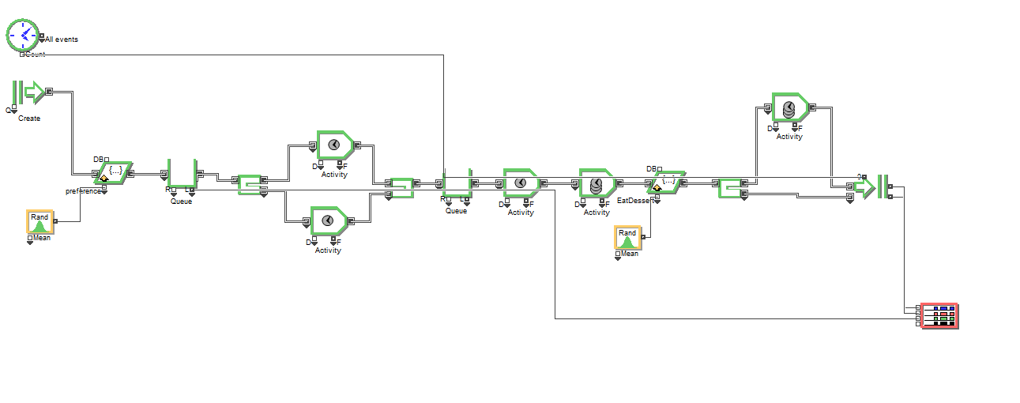

1. Create Item:

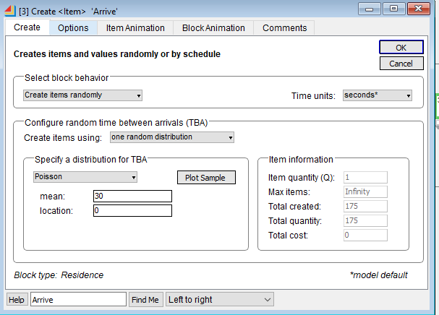

1. Results of waiting Queue

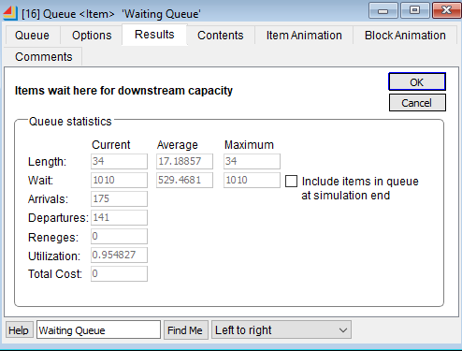

1. Activity – Sandwich – Waiting to Collect Sandwich while it is being prepared

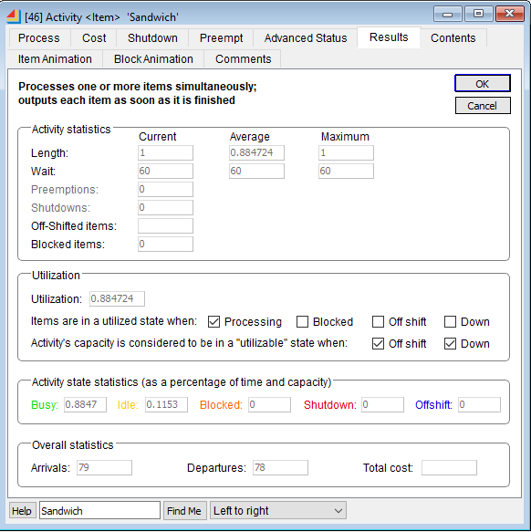

1. Activity – Meal – Waiting to Collect Sandwich while it is being prepared

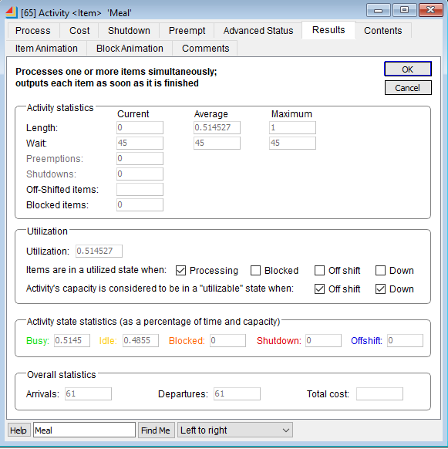

1. Results of Payment Queue

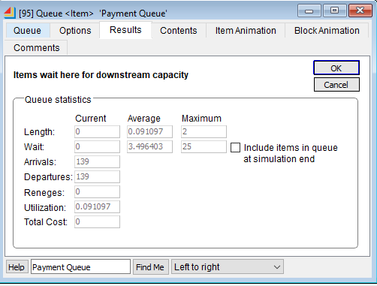

1. Activity Cashier

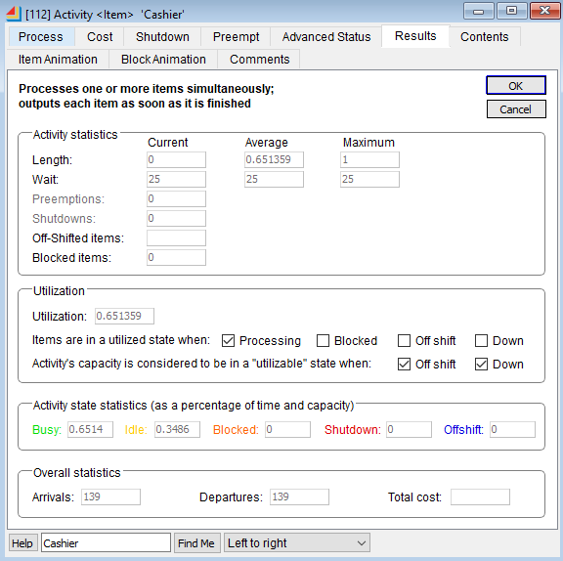

1. Activity – Table – Customers are eating on the table

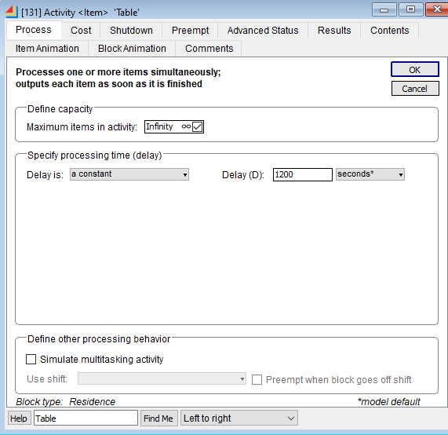

1. Activity – Desserts

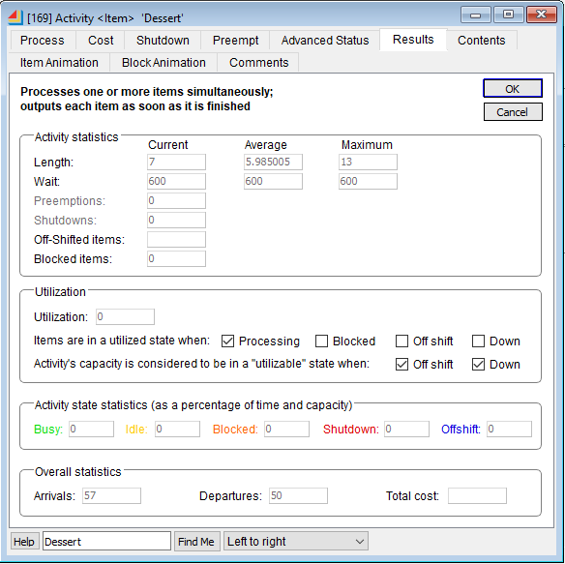

1. Exit Report

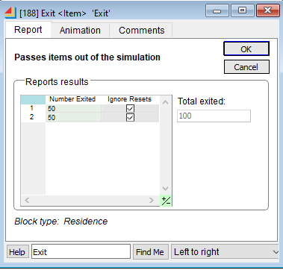

**Output**: *(Printed results i.e. the plotter data)*

Plotter data:

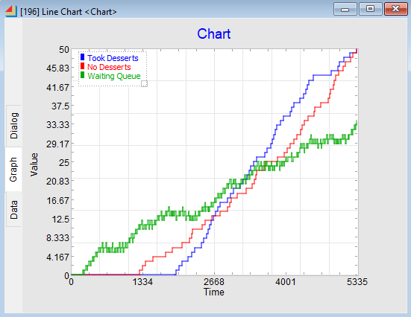

# Questions:

1. List some features when selecting simulation software.

Ans)

* Ability to create new modeling construct and to modify existing ones.
* The software should have a good debugging aids such as interactive debugger.
* Fast model execution speed
* Ability to define and change attributes for entities and also global variables and to use both in decision logic
* The availability of built-in animation is one of the reasons for the increased use of simulation modeling
* Ability to use mathematical expressions and mathematical functions
* It is desirable to be able to develop user- friendly model “front ends” when the simulation model is to be used by someone other than model developer.

2. Give the physical basis for selecting distribution

Ans)

1) Poisson: The Poisson distribution describes complete randomness and independence. It can model the number of events occurring in a fixed time interval (people arriving in a queue

(individually, not in groups), accidents at an intersection) or the number of raisins in a bun

(if they don’t stick together) or the number of weeds in your garden (if they spread

randomly rather than dropping their seeds straight down. The events have to occur

randomly and independently in time or space.

It is also an approximation to the binomial distribution if the number of trials is large and

the probability of success is small.

2) Exponential

Exponential distributions are widely employed in product dependability estimates, or

determining how long a product will survive.

3) Normal

A normal distribution is a distribution that is solely dependent on two parameters of the data

set: mean and the standard deviation of the sample. Mean — This is the average value of all

the points in the sample that is computed by summing the values and then dividing by the total

number of the values in a sample.

3. What is the purpose of Output analysis?

Ans) Output analysis is the modeling stage concerned with designing replications, computing statistics

from them and presenting them in textual or graphical format. Output analysis focuses on the

analysis of simulation results (output statistics). It provides the main value-added of the simulation

enterprise by trying to understand system behavior and generate predictions for it.

**Outcomes**: **CO3:** Analyze simulation results to reach an appropriate conclusion

**Conclusion: (Conclusion to be based on outcomes)**

We created a model for Cafeteria using ExtendSim which runs till 100 customers have left the system. We calculated the performance of the system and found the following.

When the simulation ends 74 people are still in the system:

1. 34 people are waiting in the waiting queue (have not selected the meal yet)
2. 1 person is waiting on the Sandwich counter
3. 32 people are eating their food on the Table
4. 7 people are collecting their dessert

The average waiting time of the customers in the waiting queue is 529.46 seconds.

The average waiting time in the payment queue is 3.49 seconds

The utilization of Sandwich Counter 88.4%

The utilization of Meals Counter 51.4%

The utilization of Cashier Counter 65.1%

**Grade: AA / AB / BB / BC / CC / CD /DD**

**Signature of faculty in-charge with date**

**References:**

**Books/ Journals/ Websites:**

**Text Book:**

Banks J., Carson J. S., Nelson B. L., and Nicol D. M., “Discrete Event System Simulation”, 3rd edition, Pearson Education, 2001.

# Additional Web Resources:

* Extend sim Users Guide
* Real Queuing Examples:<http://www2.uwindsor.ca/>hlynka/qreal.html

This site contains excerpts from news articlesthat deal with aspects of waiting lines.

* ClearQ:<http://clearq.com/>This company produces “take-a-number” systems for service facilities (e.g., delis), but also provides performance information about the waiting line.
* Qmatic:<http://us.q-matic.com/index.html>Thiscompany produces informational displays and other products to keep customers informed about waiting times.
* “Queuing Presentation” by Richard Larson, given at the Institute for Operations Research and the

Management Scienc[es:http:](http://caes.mit.edu/people/larson/MontrealINFORMS1/sld001.htm)//[caes.mit.edu/people/larson/MontrealINFORMS1/sld001.htm.](http://caes.mit.edu/people/larson/MontrealINFORMS1/sld001.htm)

* The Queuing Theory Tutor:<http://www.dcs.ed.ac.uk/home/jeh/Simjava/queuei>ng/mm1_q/mm1_q.html

This site has two animated displays of waiting lines. The user can change arrival and service rates to see how performance is affected.

* Myron Hlynka’s Queuing Page:http:www2.uwindsor.ca/hlynka/queue.html

This Web site contains information about waiting lines as well as links to other interesting sites.

* Queuing ToolPa[k:http:](http://www.bus.ualberta.ca/aingolfsson/qtp/)/[/www.bus.ualberta.](http://www.bus.ualberta.ca/aingolfsson/qtp/)c[a/aingolfsson/qtp/](http://www.bus.ualberta.ca/aingolfsson/qtp/)

The Queuing ToolPak is an Excel add-in that allows you to easily compute performance measures for a number of different waiting line models